Dr. Abdulrhman Said Elbnnani
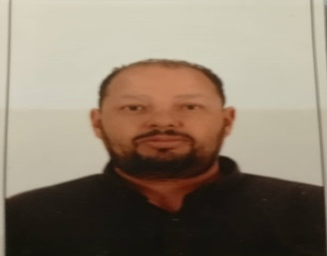

MSc , Bari Aldo Moro University, Bria , Italia 2015
Cell and Tissue Culture Department, Libyan
Libyan Biotechnology Research Centre, Tripoli, Libya.
Phone Cell: +218 944533466
Email: abdulrhmanelbnnani@jmail.com
Professional Experience
- Researcher at Cell and tissue culture department (BTRC) (2006-2025)

Recent Publications

- Elbnnani AS, Elbasir M, Altabal S, Lamami Y, Ebrahim F, Oshah HM, Alagnef R, Elzagheid A, Abulayha AM. Flow cytometric detection of leukemic blasts in Libyan pediatric patients with acute lymphoblastic leukemia. Libyan J Med. 2024 Dec 31;19(1):2319895. doi: 10.1080/19932820.2024.2319895. Epub 2024 Feb 23. PMID: 38394044; PMCID: PMC10896131

For more information, please see the following links

https://www.researchgate.net/profile/abdulrhman elbnnani

